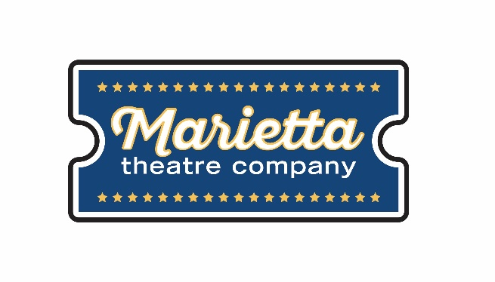

For more information:
Laurel Haislip
BRAVE Public Relations
404.233.3993
lhaislip@bravepublicrelations.com
FOR IMMEDIATE RELEASE

Marietta Theatre Company rocks and rolls with The Marvelous Wonderettes, April 13 –28
Theatergoers invited to time travel to the 50s and 60s with timeless pop production

Marietta, GA (March 26, 2018) – Audiences are invited to rock, pop and doo-wop to the sounds of the Marietta Theatre Company’s latest musical production --The Marvelous Wonderettes! Written and created by Roger Bean, the tribute to the timeless tunes from the 1950s and 1960s is set to take audiences on a melodic journey back in time when boys, big hair and bigger singing dreams occupied the minds of the Springfield High School Wonderettes. Playing from April 13 through April 28 at the Lyric Studio on the Square, this off-Broadway hit is a colorful concert fit for the whole family.

In the midst of vying for prom queen and the hearts of their crushes, The Wonderettes are asked to entertain their peers at the 1958 Springfield High School prom. Cindy Lou (Meaghan Paetkau), Missy (Chelcy Cutwright), Betty Jean (Sarah Watkins) and Suzy (Collean Cooke) deliver in their solos and four-part renditions of 1950s pop hits. However, internal struggles for power and love among the group of friends dim the spotlight on each of the girls and their friendship. A decade later, ignited by the social shifts of the 1960s, the quartet reconvenes on stage at their high school reunion to find themselves and each other once again.

Under the creative direction of Elizabeth Weaver, Laurel Henson and Nicole Gray, The Marvelous Wonderettes is a musical mashup featuring over 20 chart-topping songs from the decades that birthed popular music in American culture. Theatergoers and music lovers alike are invited to downtown Marietta to experience this theatrical singing sensation like no other!

The Marvelous Wonderettes is the fourth of five productions in Marietta Theatre Company’s inaugural season. The remaining 2017-2018 productions include the following:

- The Marvelous Wonderettes: April 13 – 28, 2018
- [title of show]: June 8 – 23, 2018

The Marvelous Wonderettes will show at the Lyric Studio on the Square from April 13 – April 28, Thursdays – Saturdays at 8 p.m. and Sundays at 3 p.m. Tickets start at $25 and are on sale now at https://mariettatheatre.tix.com. Individual tickets, VIP tables and season subscriptions for the remaining shows are also available for purchase.

“Our audiences have expressed overwhelming support for our inaugural season and we plan to keep the bar high once more with The Marvelous Wonderettes,” said Blaine Clotfelter, president and co-founder of Marietta Theatre Company. “We could not be more proud of our brilliant cast and directors for bringing this off-Broadway musical story to life right here in Cobb County!”

For more information on Marietta Theatre Company and the 2017-2018 season, visit mariettatheatre.com or follow along on Facebook and Instagram using the hashtag #TheMarvelousWonderettesMarietta.

About Marietta Theatre Company:
Marietta Theatre Company (MTC Players, Inc.) is a domestic 501(c)(3) with a mission to provide an atmosphere for the community to experience life together and introduce patrons to outstanding local talent all while supporting local charities. To stay updated on Marietta Theatre Company's latest news and performance schedule, join their email list by visiting www.mariettatheatre.com/join-our-email-list/.

